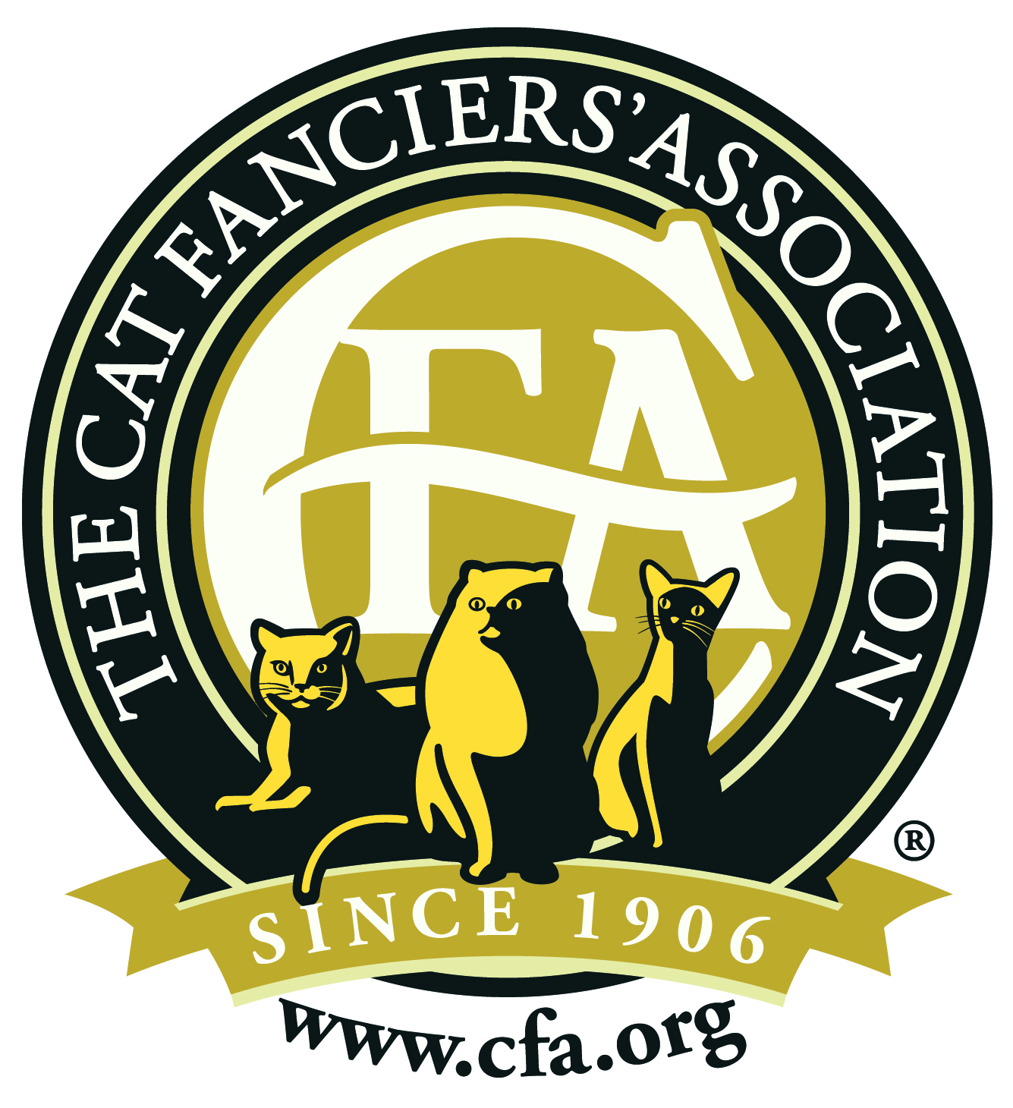
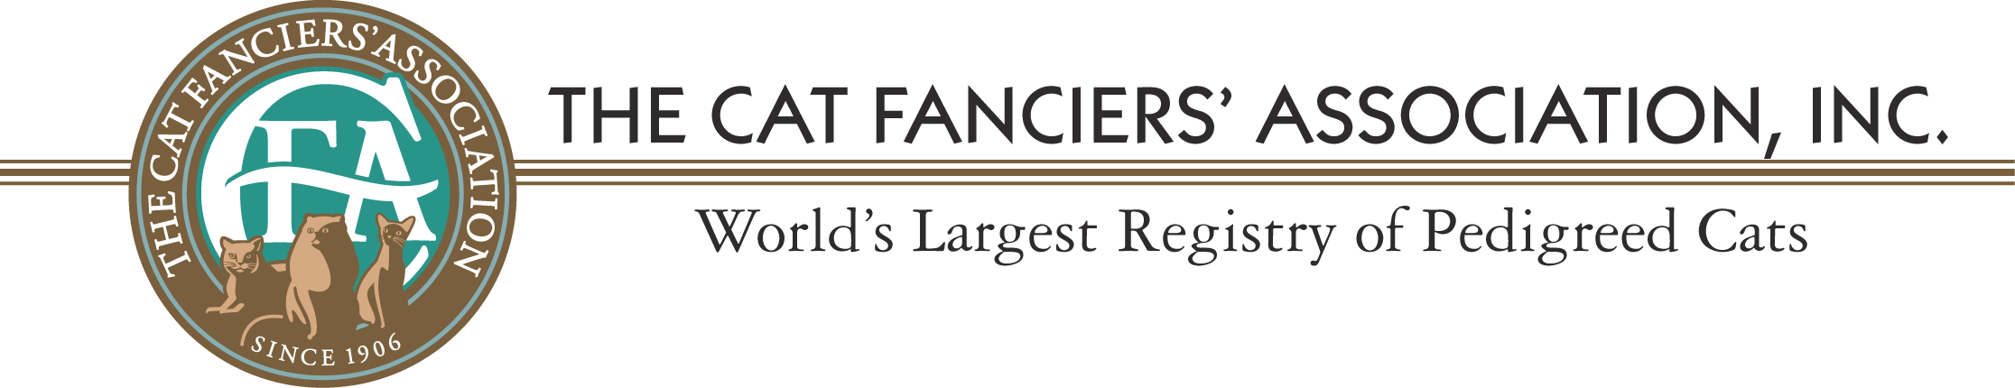

FOR IMMEDIATE RELEASE
Date: July 6, 2015 Phone: 217/351-6373 Email: mary@maryauth.com

FOR IMMEDIATE RELEASE

Champaign Cat Takes Top International Honors in
The Cat Fanciers’ Association

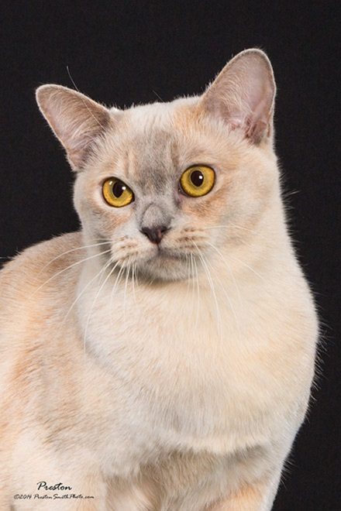
JULY 6, 2015, CHAMPAIGN IL. Mary Bryan of Champaign was in Toronto, Ontario Canada over the weekend to accept the 13th Best International Cat for the Cat Fanciers’ Association (CFA). Grand Champion CU-Cats KanoonKili was among 25 top honorees at CFA’s Awards Banquet at the Westin Harbour Castle Hotel on July 4, 2015. “Kili”, bred and owned by Mary Bryan is a Lilac Tortie European Burmese who defeated more than 10,000 cats from around the world for the honor.

“I’m so proud of Kili and what she means for the European Burmese breed. I wish more people would show in CFA so that we could showcase these beautiful award-winning cats on a local level.”

Among the other top winners were cats from the United States, Russia, Italy, China, France and Spain.

The Cat Fanciers’ Association, Inc.™ (CFA) was founded in 1906 as a not-for-profit association of member clubs and is the world’s largest registry of pedigreed cats. CFA’s mission is to preserve and promote the pedigreed breeds of cats and to enhance the well being of ALL cats. CFA promotes education, responsible cat ownership and proper care to the owners of millions of cats worldwide. CFA and its affiliate clubs work nationally with local shelters to help humanely reduce homeless and feral cat populations and to encourage voluntary neuter/spay of pet cats. To learn more about the Cat Fanciers’ Association, the pedigreed breeds of cats, or to find the nearest CFA cat show, visit their web site at www.cfa.org

